**LOAFR Github / Document Changes:**

*History of all documents included in this project, including Github*

*—------------------------------------------------------------------------------------------------------------------*

**LOAFR Github Commit History**

*Starting after 4/11/2022*

[*https://github.umn.edu/BISHO210/LOAFR*](https://github.umn.edu/BISHO210/LOAFR) *(Make sure to be logged into your UMN school account)*

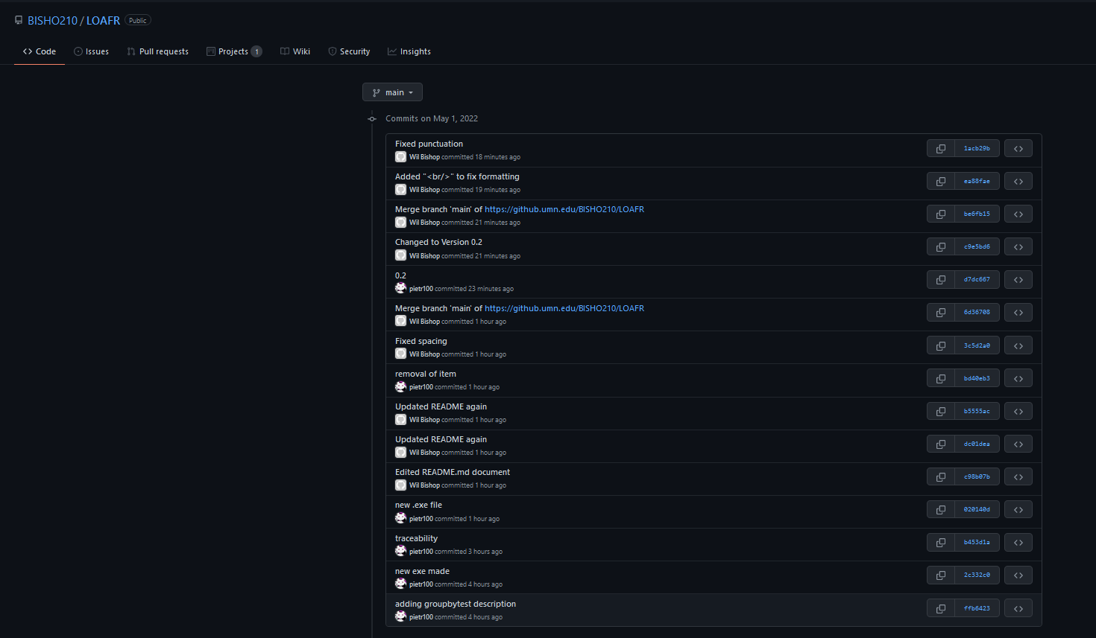

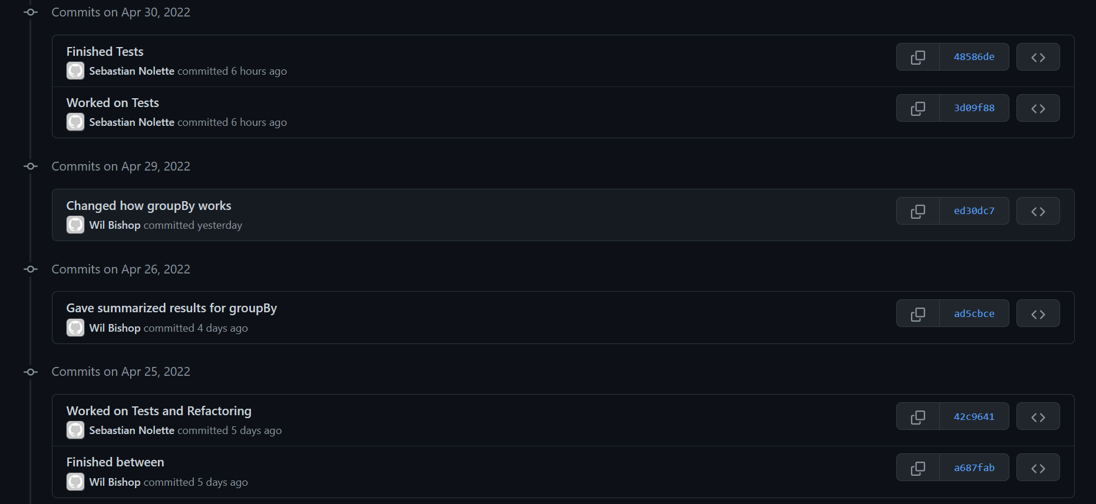

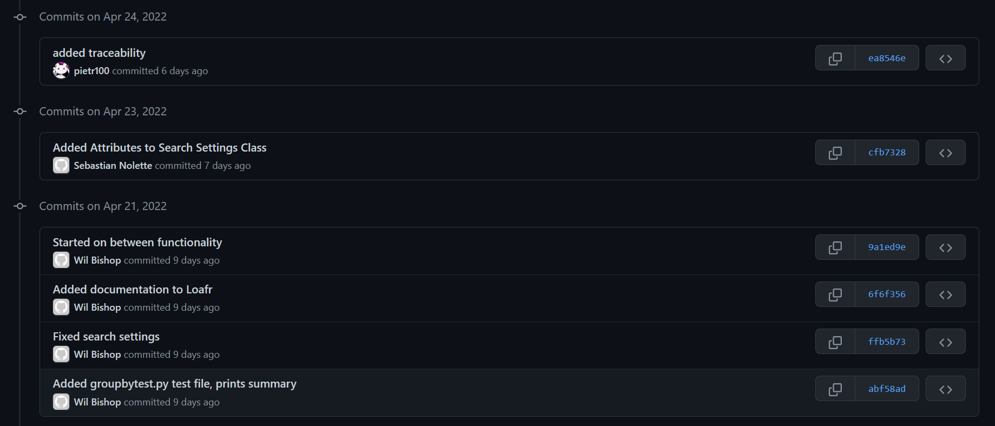

*Continuation on next page*

**Design Document Change History**

*Note: This document was cloned from our original LOAFR Design Document. It was cloned for P5 and updated for P5 only. That is why it only shows “Ashlyn” as the sole author. Items were updated / included for traceability purposes in the Design Document on 5/1/2022.*

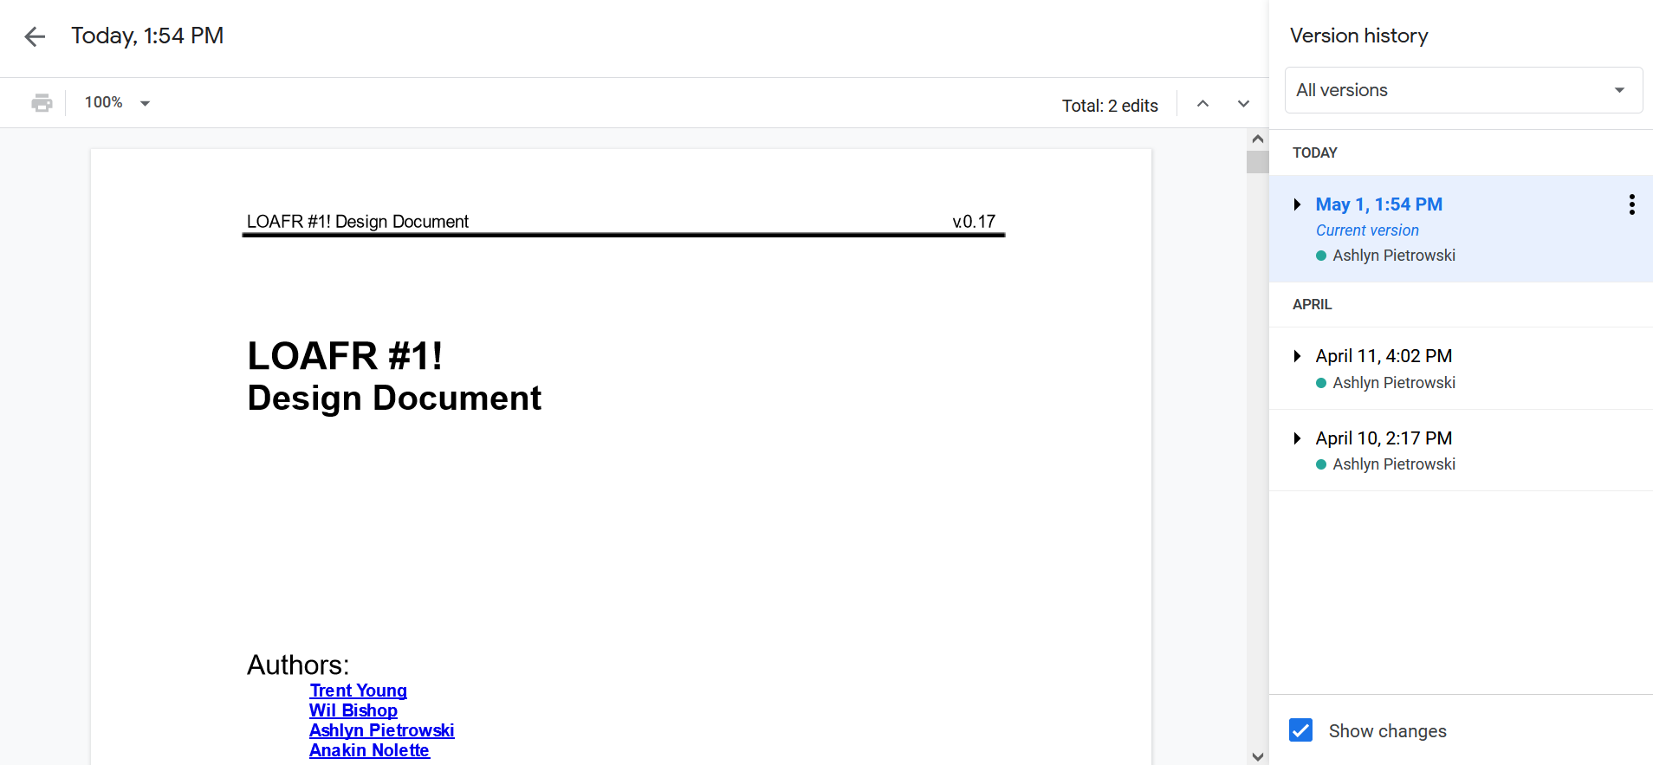

**Trello Card Information History**

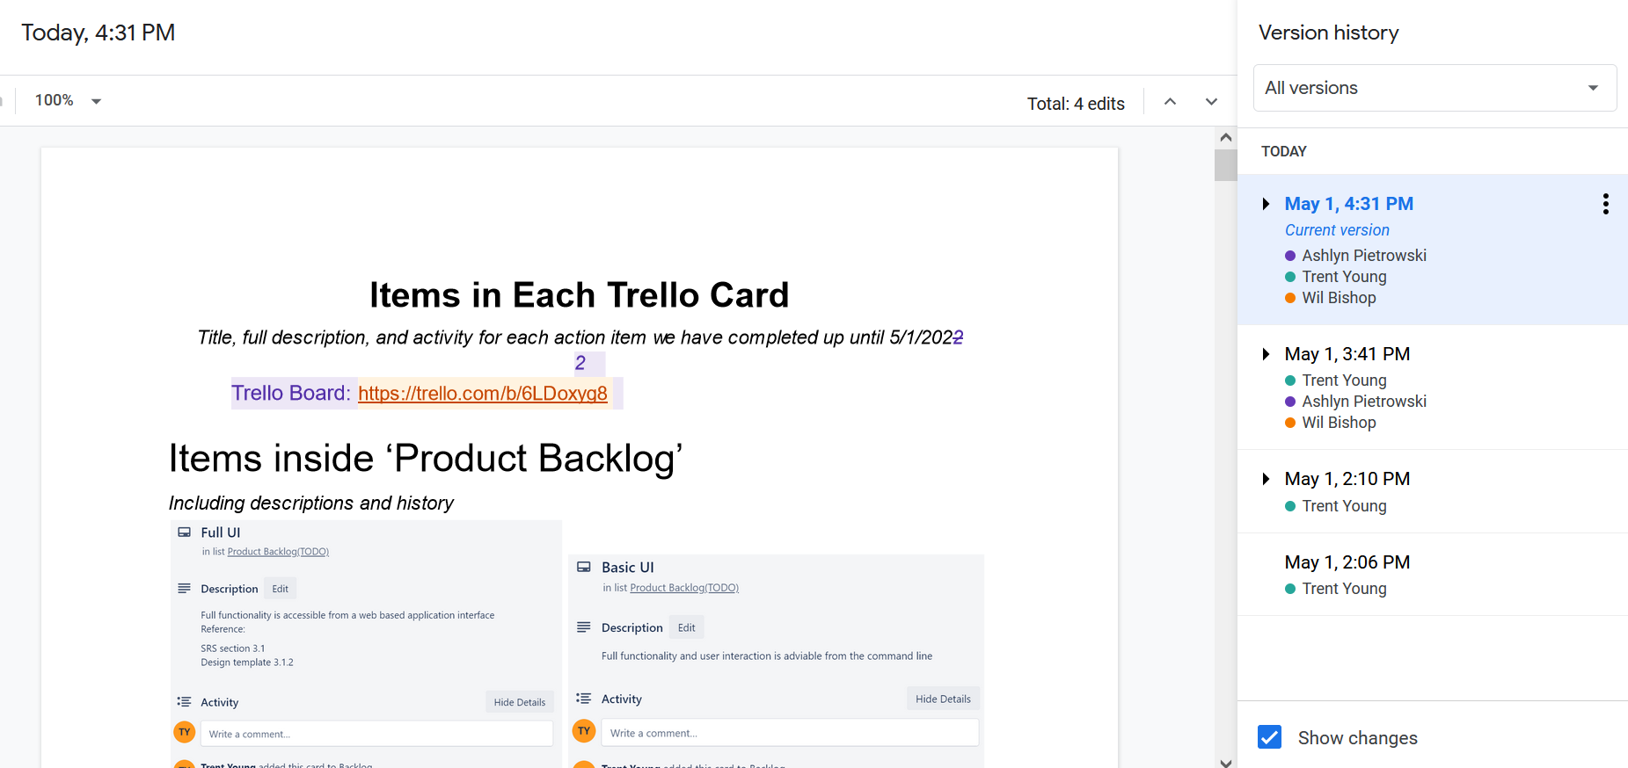

**P5 Test Execution Report History**

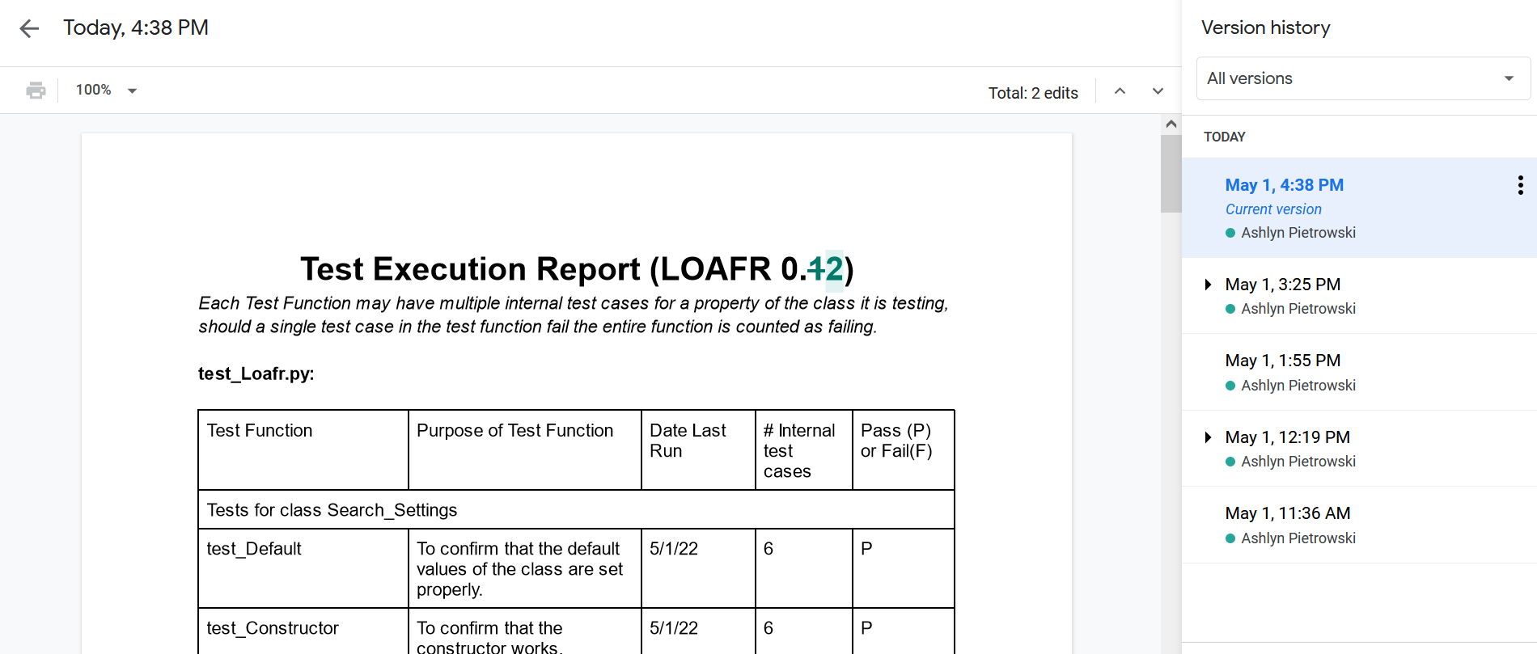

**Daily SCRUM Meeting Log**

